This is a draft of chapter 2 of an upcoming book by Yuval Laor (yuvallaor@gmail.com)

Chapter 1: Introduction
Chapter 2: Belief attachments, fervor and the types of love
Chapter 3: The causes of awe
Chapter 4: The effects of awe
Chapter 5: Neurological aspects
Chapter 6: Cults
Chapter 7: The evolution of belief attachments, awe and fervor
Chapter 8: The benefit of belief attachments, awe and fervor
Chapter 9: Case study—Scientology
Chapter 10: Conclusions
Appendix 1: The handicap principle
Appendix 2: Evolution
Appendix 3: Complexity theory
Appendix 4: Authority

2. Belief attachments, fervor and the types of love
Humans as domesticated animals
We are not wild animals. Over the course of human evolution we have become domesticated, as have our pets and our farm animals. When we look to the animal world in an attempt to better understand ourselves, we should pay particularly close attention to other domesticated social mammals. In some ways, we are closest to chimpanzees and bonobos, but in others we are closer to domesticated dogs and cats.
Domestication is primarily concerned with reducing an animal’s aggression. Such reduced aggression can be general or, as in the case of guard dogs, only directed toward specific individuals. Domestication’s reduced aggression is achieved by extending birds’ and mammals’ natural lack of aggression toward their family members. Even in highly aggressive species, such as wolverines, a mother is not aggressive toward her offspring, and while the pups are sometimes playfully aggressive toward the mother and each other, they are not trying to cause real harm.
Domesticated mammals are less aggressive toward their companions because they can easily bond with unrelated individuals and see them as family members. But love does not simply reduce aggression—it also increases aggression toward perceived threats to an animal’s loved ones.
Domestication has made it possible for loving relationships to be established throughout a domesticated animal’s life, and the different types of love—such as parent-to-child and child-to-parent love—can be combined in ways that would never occur in the wild. Such combinations are possible because, unlike their wild counterparts, mature domesticated mammals can continue to exhibit child and adolescent behaviors.
The domesticated cat is a good example. A mature house cat acts like a kitten and treats its humans as parents when it purrs, or when it is kneading (rhythmically alternating the paws, pushing against a pliable, soft object); it treats its humans as siblings when play-fighting with them; and treats them as kittens when showing them how to groom, by grooming in front of them, and by bringing progressively less damaged prey, in an attempt to teach them to hunt on their own. In contrast, once a wild bobcat achieves maturity it no longer displays kitten-like behavior.
Like house cats, adult humans can display child and adolescent psychologies and behaviors. We are able to establish loving relationships throughout our lives, and there is a wide range of who or what a human can love or attach to. It is not uncommon for people to love nations, deities, or sports teams, as well as physical objects such as paintings, cars, or guns.
Let us consider the various types of love before discussing the claim that belief/fervor should also be thought of as a type of love.
Types of love
Both wild and domesticated mammals experience the basic types of love that reduce aggression and maintain the mother-offspring relationship. These include mother-to-child love, child-to-mother love, and love between siblings. At a certain stage in the offspring’s development we see that child-to-mother love changes into adolescent-to-mother love, in which the offspring still loves its mother, but increasingly enjoys independence from her.
In domesticated animals the types of love are transformed into prototypes of love. This means that an attachment relationship can resemble one of the prototypes of love even though that prototype does not match the actual nature of the relationship [Footnote: the loosening of the roles that the types of love play is also seen in species termed as cooperative breeders. In these species the offspring receive care not only from their parents, but also from additional group members]. For example, it is possible for an adult human to love her parent the way a parent loves a child, and for a parent to be dependent on her child and love her the way that children love their parents.
Another consequence of human domestication is that humans may display more than one type of love within a given relationship. For example, a couple can be romantically attached, while one (or both) of the partners is psychologically dependent on the other, a characteristic typical of child-to-parent relationships.
The basic mammalian types of love
Parental love
Parental love is the type of love that bonds mammalian mothers, and in some species fathers, to their offspring. Mammalian motherly love manifests as one of two modes; I will refer to these as sober parental attachment and infatuated parental attachment. While both show unconditional dedication to the object of affection, a mother in the infatuated mode is much more vigilant and protective of her young, sometimes to the point of sacrificing herself for the wellbeing of the offspring.
Motherhood tends to start out in the infatuated mode (but not always, especially in domesticated animals) following a strong emotional experience of “falling-in-love” with the newborns. This usually happens in the context of giving birth, but giving birth is not necessary, as adoption is observed in many species. As time passes, the mother’s love turns from infatuation to sober attachment. In the sober mode the mother is less obsessive regarding her young, but her infatuation can return at any moment if she suspects that her offspring are in danger.
In wild mammals, parental attachment, with its potential for infatuation, fades with time so that the mother will allow her grown offspring to become independent. In humans, who thanks to domestication are much more flexible regarding attachment relationships, parental love can fade or take various forms as the children reach adulthood.
Child-to-parent love
As its name suggests, child-to-parent love governs the attachment that young mammalian offspring have toward their parents. In humans and other domesticated mammals this psychological state can be displayed throughout life. This type of love is marked by trust and dependence of the child or the person in the role of the child on the person (or entity) which represents the parent. In general, preadolescent human children adopt their parents’ worldview and way of life without question.
Adolescent to parent love
In most wild mammals, adolescence is a transitional period where the child-to-parent love diminishes, culminating in the offspring leaving their mothers. In many social mammals this is the time of life when one or both of the sexes move from one group to another. In many human societies it is common for adolescents to have conflicts with their parents, sometimes resulting in the child rebelling against the parents or even becoming estranged from them.
Once children are grown, their relationship with their parents might change to resemble another love prototype. In many cases, the resulting relationship comes to resemble the prototype of love between siblings or between extended family members.
Love between siblings
In wild mammals the love between siblings from the same litter keeps them from being aggressive toward each other. Often there is some level of sibling rivalry, and the siblings tend to play-fight with each other, but this is not real fighting. The relationship between siblings who are not the same age resembles to some extent the relationship between a parent and a child without the responsibility that ultimately falls on the actual parents in case of an emergency. But as I have been arguing, domestication makes loving relationships more plastic, which means that the relationship between domesticated mammal siblings can also resemble the other prototypes of love.
Types of love which are only seen in certain mammals
Romantic love
Around five percent of mammal species (but around 90% of birds) display romantic love. In these species, the father is included in the family, and mother-to-child and child-to-mother love becomes parent-to-child and child-to-parent love, as both parents tend to raise the offspring. In such species the bond between the parents is formed through romantic love.
Romantic love is not a basic mammalian type of love, since most mammals do not attach romantically. It seems that romantic love came about when evolution combined aspects taken from the basic types of love with behaviors associated with courtship and mating.
Earlier, I discussed how parental love has two modes, sober and infatuated. This aspect of parental love was carried over to romantic love, which also has a sober and an infatuated mode. In her classic work Love and Limerence (1998), Dorothy Tennov suggests that romantic infatuation, which is sometimes referred to as being-in-love, is sufficiently different from genuine love to deserve its own term which she called limerence. The obsessive limerent mode of romantic love is the subject of many popular songs, movies, and works of literature. It is also the cause of much heartache and of many crimes of passion, sometimes reaching a level of despair that can result in murder or suicide.
Love between extended family members
In certain mammals extended family members act as alloparents—helping the mother or the parents raise their young (Hrdy, 2009). Such group behavior, called cooperative breeding, can be seen in, among others, marmosets, wolves, meerkats, and humans. It seems that this is not a basic type of love, but that the relationship between alloparents, parents and offspring, resembles one or more of the basic prototypes of love.
Belief and fervor, a new type of love
A central argument in this book is that the various prototypes of love, whose scope and variation have been impacted by human domestication, interacted with elements of child psychology and with symbolic language, resulting in a new type of love which I will refer to as belief attachment. Like the parental and romantic types of love, belief attachments come with sober and infatuated modes. I refer to the infatuated mode as fervor.
Most types of love include a commitment to another person. In belief attachments, the commitment is not limited to a person, but can also be directed toward deities, a group, way of life, and the truth-value of a set of ideas. In many cases, a belief attachment is directed toward a doctrine which includes infallible authority figures and infallible texts, one or more deities or deified persons, an authority structure, various norms and traditions, a worldview, motivations, attitudes, beliefs, and behaviors.
I define belief system as the collection of elements a belief attachment is directed toward. Belief systems often take the form of a faith, an ideology, or as an entity such as a group or a nation that the person identifies with. As in the other types of attachment relationships, belief attachments can resemble more than one love prototype. For example, a cult member’s belief attachment may include a dependent relationship with the cult leader, and fervor toward the group and its ideology. The dependent aspect of the cult member’s belief attachment resembles child-to-parent love, while the fervor she has toward the group resembles parental infatuation, as the cult member selflessly sacrifices her time, money, and energy in an effort to promote and defend the group

Characteristics shared by the parental, romantic and belief attachments
I argue that belief attachment and its infatuated mode of fervor, is evolutionarily related to the prototypes of love, particularly to the parental and romantic types of love. This relationship is evident in various similarities between belief attachments, parental love, and romantic love. These include:
- The states of attachment depend on an underlying emotion, or cluster of emotions. In the case of parental and romantic attachment the emotion is love, while in the case of belief the emotion is awe.
- Each of these attachments has two modes, sober and infatuated. I refer to the infatuated modes as parental infatuation, limerence, and fervor.
- The attachments and their respective infatuations are maintained by a feedback between love/awe experiences that maintain the attachment, and behaviors that come about as a result of the attachment, and which induce additional love/awe experiences.
- With time and a sense of security, the infatuated states tend to settle into their respective sober attachments.
- The states of attachment include a strong commitment which is not based on cost-benefit considerations. These commitments are particularly strong when a person is infatuated.
- Infatuated people feel a strong sense of importance and urgency, making them motivated and goal directed. In some cases this makes them seem selfish.
- Infatuation can lead to neglect of other obligations and relationships.
- Underlying the attachments are special “feelings-of-knowing.” In the case of parental and romantic love these include a special certainty regarding the identity and value of the loved one. In the case of belief attachment, the special feelings of knowing also include a special certainty regarding the truth value of a set of ideas, the infallibility of certain figures or deities, and the correctness of various social norms.
- The attachments, particularly in their infatuated modes, give people the feeling that their life has meaning and purpose.
- The states of infatuation include blind spots, so people see only an idealized version of whatever or whoever they are infatuated with. When the person reverts to the sober mode of attachment these blind-spots can vanish, remain intact, or they can be transformed into willful ignorance.
- Infatuation includes a heightened sensitivity to criticism.
- The infatuated modes induce intrusive thoughts and at times include obsessive, addiction-like behaviors.
- From adolescence onward many people crave infatuation.
- Stressful and traumatic events or situations can reignite or sustain a person’s infatuation.
- Stress and anxiety can be soothed by thinking about objects of attachment such as loved ones, religious beliefs, deities, or authority figures.
- Chronic stress (including trauma, anxiety, urgency, guilt, insecurity, uncertainty, etc.) can make it easier for people to experience awe and to fall in love, either parentally or romantically.
- The attachments can be established in a very sudden manner following a strong emotional experience which is somewhat involuntary and beyond description. Such a sudden onset of attachment starts out in the attachment’s infatuated mode.
- When these attachments are established suddenly, as opposed to gradually, their onset makes it possible for people to change their lives dramatically.
- The sudden onset of limerence and fervor (and in some societies, parental infatuation) is more common among adolescents and young adults.

Establishing Infatuation: Noetic experiences and falling in love
While becoming infatuated can come about gradually, the infatuated states—including fervor—can be established suddenly following a strong involuntary emotional experience. Romantic infatuation can follow a romantic falling-in-love event, and parental infatuation can be established by parents “falling-in-love” with a child (I also refer to parents forming a bond with a baby as “falling-in-love”). In the case of belief attachment, the establishing experience can take the form of a sudden religious or ideological conversion.
As I will discuss in the next chapter, traumatic events, perceived vastness, encounters with celebrities and observing an inexplicable event (especially one which is deemed to be miraculous) can, among other triggers, bring about awe, and sufficiently intense awe experiences can manifest themselves as mystical experiences. These can function psychologically as proof of unrelated claims because of what William James calls their noetic quality (the term “noetic” means relating to knowledge).
As discussed earlier, belief attachments include a commitment to a belief system that might embrace ideas which are unwarranted and mistaken. An example can be seen in the biblical account of the misperception of Jesus’s disciples when observing him walk on water:
“Jesus made the disciples get into the boat and go on ahead of him to the other side… Shortly before dawn Jesus went out to them, walking on the lake. When the disciples saw him walking on the lake, they were terrified. ‘It’s a ghost,’ they said, and cried out in fear. But Jesus immediately said to them: ‘Take courage! It is I. Don’t be afraid.’” (Matthew 14: 22-27, New International Version)
This account shows that there can be more than one way to interpret an inexplicable event. The disciples’ initial interpretation is that the figure walking on the water is a ghost. But Jesus points out that they should interpret the event as a “miracle.” In fact, the “miraculous” event may be taken to support a host of assumptions, none of which can be deduced directly from Jesus’ unusual buoyancy.
There seems to be a connection between observing an inexplicable event deemed to be miraculous, and relying on these to support unrelated conclusions. To understand the mechanics of such leaps of logic, we need to look at the strong feelings of awe that can be induced by observing an inexplicable event.
James argues that mystical experiences have a noetic quality because “Although so similar to states of feeling, mystical states seem to those who experience them to be also states of knowledge. They are states of insight into depths of truth unplumbed by the discursive intellect. They are illuminations, revelations, full of significance and importance, all inarticulate though they remain; and as a rule they carry with them a curious sense of authority for after-time” (1901, 1985 p.302).
While James describes these “states of knowledge” as a feature of mystical experiences, the noetic quality can also be present in other awe experiences which include secular epiphanies. I define noetic experiences as the subset of awe experiences which coincide with expectations and assumptions that makes them feel like “states of insight into depths of truth.”
The difference between awe and noetic experiences is similar to the difference between fear experiences in general, which might be felt while watching a horror movie, and the subset of fear experiences that are attributed to a real threat.
I maintain that the experiences that James describes as having a noetic quality are similar in many ways to sudden falling-in-love experiences. Whereas sudden falling in love is likely to result in limerence or in infatuated parents, noetic experiences can bring about the infatuated state of fervor.
Like noetic experiences, falling-in-love experiences are states of feeling that seem like states of knowledge. But in the case of falling in love, the knowledge does not reveal a truth, but establishes the certainty that the parent and the baby, or the romantic partners, are meant to be together. As James says of mystical experiences, falling-in-love experiences are also “full of significance and importance,” and “carry with them a curious sense of authority for after-time.”
Consider this account of a group of couples who traveled to China to adopt a baby. The morning after each couple had received a baby at the orphanage, the adoptive parents met over breakfast and shared the opinion that the woman who had handed out the babies was a genius. She knew exactly which baby should be given to which couple. Although they were aware that the babies were handed out randomly, the love the new parents felt toward their baby made them feel that their baby was meant specifically for them. It was hard for them to imagine caring for another couple’s baby as much as they cared for the one they had fallen-in-love with. [To anyone reading this chapter, I can’t remember where I read this, do you know where this story is from?.]
In this case, parental infatuation provided a sense of certainty regarding the identity of the loved one. The story of Romeo and Juliet, who are certain that they are meant for each other, is a good example of certainty in the context of romantic infatuation.
The emotions underlying the attachments
The states of parental and romantic attachments depend on underlying emotions such as love, compassion, affection, liking, fondness, and caring. These emotions can be collectively referred to as the emotion of love. Similarly, underlying belief is a cluster of emotions that include awe, wonder, mystery, effervescence, and a sense of the sublime. I will refer to these collectively as awe.
I maintain that awe and love interact with a class of “feelings-of-knowing”—subjective experiences that feel like, but are not, objective knowledge. Before continuing, I need to present a brief introduction to the nature of such feelings.
Feelings-of-knowing
In his book On Being Certain (2008), neurologist Robert A. Burton describes a number of feelings-of-knowing which he considers to be both sensory and reward systems. These include the mental sensations of certainty, conviction, rightness (as opposed to wrongness), correctness, familiarity, realness (which includes authenticity, and is the opposite of being fake), and the sense of truth that TV host Steven Colbert has called truthiness.
These feelings-of-knowing color our experience. Differences in the feelings-of-knowing account for differences between seeing something in real life, seeing it in a movie based on a true story, or in a movie we know is fictional. It also explains the difference between how we feel when viewing (what we consider to be) an authentic Da Vinci painting, a reproduction, or a fake (a reproduction presented as real).
Just as optical illusions teach us about vision, the nature of the feelings-of-knowing is illuminated by cases where they go astray. Déjà vu experiences and “tip of the tongue” sensations are good examples. In the latter, we know that we know something, and while we don’t know what that something is right now, we expect the knowledge to come to us at any moment. Other examples can be seen in medical conditions that cause people to be delusional.
Feelings-of-not-knowing include uncertainty, doubt, unfamiliarity, feeling that something is wrong, incorrect, fake, or false. Examples of these feelings misfiring can be seen in jamais vu, where we feel inappropriate unfamiliarity, in those undergoing a crisis of faith, and when we are convinced that we are being lied to, that something is “fishy” or does not “feel right.” Pathological uncertainty can be observed in those who suffer from obsessive-compulsive disorder (OCD), where some people continuously feel that they might have left the stove on, never able to shake their chronic feeling of uncertainty, as they check and re-check the stove.
Sometimes the feelings-of-knowing contradict logic. One example is delusional misidentification syndrome (Christodoulou, 1986), where people believe that the identity of a person, object, or place has somehow changed or has been altered. In some cases people with this syndrome feel that close family members are impostors, despite all evidence showing that the family member is who they say they are. In Cotard’s syndrome patients are certain that they are dead or that they do not exist. One would think that people suffering from this condition would understand that they are wrong once they assess the situation logically. But when a feeling-of-knowing contradicts logic, the feeling-of-knowing tends to prevail, even if it requires much rationalization.
“Truth”—a feeling-of-knowing exclusive to humans
Many animals experience the feelings-of-knowing of familiarity, certainty, conviction, and correctness. Certain animals that have theory of mind (the ability to attribute mental states to oneself and to others) also have the feeling-of-knowing of realness, enabling them to distinguish between real and fake. As such, these animals are able to deceive one another, and can suspect that they are being deceived.
Humans have symbolic language, which brought with it the additional feeling of knowing of truthiness. Humans are able to distinguish between what they consider to be truths and falsities. I maintain that this feeling-of-knowing has played a crucial role in the evolution of belief, fervor, awe, and noetic experiences.
The deceptive nature of the feelings-of-knowing
Although our feelings-of-knowing are subjective, they cause the information they are connected with to feel like objective knowledge (I am trying to talk objectively about subjective experiences that make people think that something is objectively true). We do not consciously perceive a sensation of certainty about a statement such as “the sun rises in the east”—we simply know that it’s true.
Let us return to Jesus’ disciples’ conclusion that ghosts exist as way of explanation of the walk across the Sea of Galilee. It could be said that the inexplicable event induced in the disciples a noetic experience, which psychologically functioned as proof that ghosts exist. But if we had asked the disciples what happened, they would probably have said that they saw a ghost, possibly noting that it was walking on the water. The role that the awe experience played in their conviction is likely to be unappreciated. Later in the chapter, we will see how awe and noetic experiences can create “blind spots,” in this case as they relate to the lack of connection between a person walking on water and the assertion that ghosts exist.
Our lack of awareness of the role that feelings-of-knowing play in everyday life is evident in the sense of familiarity. While walking down the street, a person recognizes someone she hasn’t seen for years. In her mind, first she saw her friend, and because she knows him, he felt familiar to her. But, in fact, the feeling of familiarity must have come before she recognized her friend’s identity. Her brain was unconsciously scanning the faces of the people on the street when an internal face-recognition process triggered the feeling of familiarity; this feeling made her look at the familiar face long enough to recognize her friend.
The person experiencing the feeling of familiarity senses it as a side-effect of seeing a person they know, while in fact it is the feeling-of-knowing which made the person realize that they were seeing a friend. This is similar to the example of the inexplicable event proving the existence of ghosts mentioned above. The observers perceived the noetic experience as a side-effect of seeing a ghost, but in fact it is the feeling-of-knowing aspect of the noetic experience that caused them to conclude that they saw a ghost in the first place.
Awe and love make the feelings-of-knowing “special”
I maintain that love and awe transform the feelings-of-knowing into special feelings-of-knowing. William James describes the knowledge acquired through noetic experiences as “insight into depths of truth unplumbed by the discursive intellect.” He is not describing everyday knowledge like knowing the price of milk, but rather knowledge of something that feels special. I argue that this “specialness” is present in the various attachment states, and is heightened when people are infatuated.
An example of parental attachment causing special feelings-of-knowing can be observed in a mother bear who considers her cubs special, a feeling she does not have (but can sometimes develop) toward another bear’s cubs. She feels a special familiarity with them, a special certainty regarding their identities, and when she sees them act incorrectly she has a special urge to correct their behavior.
Popular media offers countless examples of limerence producing similarly special feelings-of-knowing directed toward the person’s limerent object. But this specialness is not limited to people in the grips of limerence, as it is also present in sober romantic attachments.
Similar to the parental and romantic attachments, believers, especially fervent believers, feel that the belief system toward which they have formed a belief-attachment possesses a special truthiness. This transforms such a belief system into one that it is not just real, but “really real.” It is common for awe, and the specialness that comes with it, to be coupled with symbols, people, objects, locations, postures, languages, speech acts, numbers, colors, food items, animals, plants, times of day/week/month/year, and occasions such as weddings or births. Each of these can have either a positive specialness that Durkheim calls holy, or negative specialness that he refers to as profane.
It is not necessary for people to actually know the information that a noetic experience made them believe is true. Believers who do not know the content of a holy book may nonetheless believe that whatever the contents of the book might be, they must be true. As William James noted: “we have the strange phenomenon, as Kant assures us, of a mind believing with all its strength in the real presence of a set of things of no one of which it can form any notion whatsoever” (1902/ 2002, p. 63).
Belief attachments, especially in the fervent mode, make us feel that a set of ideas has been proven beyond the shadow of a doubt, even when those ideas include paradoxes and contradictions. This is possible because of how feelings-of-knowing override logical thinking. In some traditions paradoxes and contradictions are emphasized. Buddhism embraces paradoxes—Zen Buddhism most famously so—as does Christianity in the doctrine of the Holy Trinity, where God is simultaneously one and three.
A belief in paradoxes or contradictions ensures that a person feels that his belief system is true. An irrationally held belief system can be very resilient, making believers less likely to leave a group when encountering events or information that contradicts that group’s faith or ideology. This is reflected in Jonathan Swift’s 1721 quote that “Reasoning will never make a man correct an ill opinion, which by reasoning he never acquired.”
Additional similarities between noetic and falling-in-love experiences
So far, we have discussed how noetic and falling-in-love experiences can lead to an infatuated state whose underlying emotion, either love or awe, makes the feelings-of-knowing special. Now let us discuss other similarities between noetic and falling-in-love experiences—namely that such experiences are more common in teenagers, and how these experiences allow us to change our lives suddenly and dramatically.
Noetic and falling-in-love experiences are more common in adolescents and young adults
Adolescents and young adults are more likely than adults to undergo both noetic and falling-in-love experiences. Sudden religious conversion has long been thought of as an event that typically occurs during adolescence and young adulthood (Starbuck, 1899; James, 2002; G. S. Hall, 1904; in Kirkpatrick, 2005, p. 151). Studies from the first half of the 20th century support this notion, showing that the most common age for conversion is (or was at the time of these studies) in the mid to late teens (P. E. Johnson, 1959; Roberts, 1965; Gillespie, 1991; in Kirkpatrick, 2005, p. 151; see also Persinger, 1987).
This phase of life is also associated with romantic love, love at first sight, having or adopting babies, and with a change of attitude toward one’s parents, as young adults leave home and start their own families. The tendency to undergo life-changing falling-in-love experiences during adolescence is not unique to humans. This is also the time in life when chimpanzee females, baboon males, and other social mammals undergo such experiences and move from one social group to another.
Earlier I argued that humans are domesticated animals that can exhibit child and adolescent psychologies as adults. This means that, although it is less common, adult humans can also undergo transformative noetic and falling-in-love experiences.
Noetic experiences and falling in love enable people to change their lives
Noetic and falling-in-love experiences allow people to dramatically change their lives. In the context of love this is seen when people change their routines to take care of a baby, or when romantic falling-in-love results in joining or establishing a new family group. In the context of belief attachments this can be seen in sudden religious (and non-religious) conversions, where people can drastically change their belief system and way of life (for discussion see Miller and C’de Baca 2001).
The transformation that can follow a noetic or a falling-in-love experience often includes a change in personal identity. In some cases, the change is cemented by adding a title to one’s name or undergoing a name change. This is often part of an elaborate and emotionally salient ceremony such as a wedding, a religious ritual, or when adopting a new group identity.
The transformation that a noetic experience can bring about is described by neurologist Michael Persinger as one that “shames any known therapy” (1987, p. 17). An example of a group taking advantage of the power of noetic experiences for transformation is seen in Alcoholics Anonymous, whose founding was influenced by the writings of William James (Finlay, 2000; Pittman, 1988, p. 170). The group’s 12-step program seeks to induce a noetic experience which will make participants rely on a “higher power” and make it possible for them to quit their alcohol addiction. Tragically, Alcoholics Anonymous insists that people hit “rock bottom” (Szalavitz, 2017) to induce their transformative noetic experience. As we will see in the next chapter, there are much less traumatic ways to induce noetic experiences.
Using the language of Kurt Lewin’s change model [ref], we can say that noetic and falling-in-love experiences bring about an “unfreezing” of the person, putting them in a malleable state making it possible for them to change their lives. The “unfrozen” state is temporary, making it likely that the changes made in the malleable phase will become semi-permanent when routine “re-freezes” the person’s culture and habits.
Resistance to the study of noetic and falling-in-love experiences
Some people resist examining the nature of awe and love, fearing that such examination will diminish the “magic” of these feelings. I disagree and think that we can better enjoy the world by learning how to experience our own sense of love and awe safely, and by gaining more control over our infatuated states. With understanding of awe and love we are less vulnerable to manipulations that make use of these powerful emotions, and are more likely to deal with heartbreak or disillusionment without having to become cynical.
The states of infatuation (parental infatuation, limerence, and fervor)
In the grip of infatuation, we tend to be obsessively preoccupied with the object of our infatuation. An infatuated person can be engulfed by intrusive thoughts and compulsive daydreams which can be either positive or negative. Dorothy Tennov, writing about limerence, notes: “The astounding thing is that the pleasantness or unpleasantness of the state seems almost unrelated to the intensity of the reaction. Limerence at 100 percent may be ecstasy or it may be despair, and it may change from positive to negative at any level of intensity.” (1979, p.45) Similarly, parental infatuation and fervor can rapidly alternate between positive and negative poles.
Infatuated states make the object of infatuation seem uniquely important. This leads the infatuated person to be motivated and goal directed, sometimes to the point of seeming selfish. In limerence and parental infatuation the goal is to establish or maintain a committed romantic relationship, or to raise a healthy child. In the case of fervor the believer’s motivations are determined by whatever the object of fervor is. In a group of fervent believers there is also the goal of achieving or maintaining high standing within the group.
When a group shares an infatuation, the infatuation can lead to powerful camaraderie. This can be seen in a group of adolescents who are infatuated with a teen idol, and in fervent followers of a sports team, a nation, or an ideology. But when a person is alone in an infatuation it can have an isolating effect. In some groups, especially those considered to be cults, followers can be dually isolated as the group becomes isolated from the world, while the cult members are isolated from each other through various methods, which will be discussed in chapter 5.
With time, and with a sense of security, the infatuated states tend to settle into respective sober attachments. Healthy and balanced children turn parental infatuation into sober parental attachment; a secure relationship makes limerence settle into a sober loving relationship; and a reassuring belief system, coupled with security within a group, can, with time, turn a person overtaken by fervor into a sober believer.
Infatuation and exclusivity
People can have multiple attachments, as long as these are in the sober mode. A parent can love multiple children, and polygamists can love multiple spouses. When it comes to belief attachments, we have examples of people adhering to more than one faith. Many Japanese people intermix Shin, Taoist, and Buddhist beliefs according to the ceremony or the season; and the biblical Old Testament is full of stories of the Jews being punished for worshiping other gods in addition to Jehovah. In an effort to avoid sharing believer’s loyalty with other faiths, many religious traditions explicitly demand exclusivity in allegiance.
While it is possible to have multiple sober attachments simultaneously, the same cannot be said of attachments in the infatuated mode. This is because infatuation engulfs us. Romeo cannot be limerent with another girl in addition to Juliet, and a fervent Scientologist is not at risk of joining the Unification Church. One might think that parental infatuation is an exception, as parents can be infatuated with more than one child. But I maintain that this is not a case of multiple infatuations but a single infatuation with multiple children.
Commitment and infatuation
Infatuated states come with a commitment toward the object of infatuation, whether it is an individual, a group, or a belief system. The latter can include a faith, an ideology, or various abstract or concrete entities. This commitment can be exceptionally strong while the person remains under the spell of infatuation. In most cases, the commitment remains stable long after the honeymoon period of infatuation diminishes. But sometimes the commitment can end along with the infatuation. This manifests as people “waking up,” and reevaluating a group or a romantic partner.
While noetic experiences can have a transformative effect that establishes a new commitment, they can also strengthen a person’s existing commitment without altering her beliefs. This is seen in events that some traditions refer to as being “born again.” A similar dynamic can be seen in romantic love, where people can have a “second honeymoon,” falling in love all over again.
Noetic and falling-in-love experiences may not only establish commitments, they can also break them. Falling in love is often how romantic relationships are established, but it can also be how they break up when one partner falls in love with someone else. With fervor, this can be seen in the way a noetic experience can lead a person to lose her faith, switch from one group to another, or in how joining a cult makes it easier for a person to sever family ties.
Sometimes a new infatuation makes it possible to break away from problematic or abusive commitments. Many cults present themselves as an alternative family, appealing to those who are in an abusive or unfulfilling family situation. Sometimes groups start their recruiting efforts by demonizing the potential recruit’s family. An example can be seen in an online cult led by Stefan Molyneux which encourages its members to “deFOO” a term they use to mean severing connections with one’s family of origin (FOO) (Stein, 2016).
In both fervor and love, our commitment is irrational in that it does not depend on cost-benefit calculations. This means that fervor can stabilize and maintain almost any cultural variation. For example, fervor can result in an individual or a group which acts as if there is extreme urgency even when, objectively, no such urgency exists. Conversely, fervor can stabilize a culture that makes people ignore urgent matters even when the situation is indeed dire. Similarly, parental love is often unconditional and the state of limerence allows a person to stay in a romantic relationship which is toxic and abusive.
Maintaining attachments
So far, we have been discussing intense experiences of love and awe, the kind of experiences that can result in infatuation and bring people to change their lives. But mundane versions of these experiences also exist. Unlike their more intense and potentially transformative counterparts, these weaker experiences serve to maintain existing commitments and relationships by reaffirming the believer’s or family member’s commitment, or at the very least reminding him or her of it.
Many religious traditions suggest or require that people perform low intensity everyday rituals, such as blessing food or praying regularly. Performing these rituals is often accompanied by some level of awe. Similarly, family members who love each other perform everyday rituals of affection. For instance, tucking in children before they go to sleep, and kissing a spouse goodbye when leaving the house. The emotions of awe and love can also be regularly induced when they are coupled with objects that a person interacts with regularly; religious people may have religious artifacts in their house, and families often display pictures of each other to remind them of their loved ones.
Without regular awe or love experiences, people’s level of fervor or love tends to drop over time. At first this leads people to switch from the infatuated to the sober mode of the attachment; and if the lack of awe or love experiences persists, the attachment itself can also diminish or become dormant. This effect might be a legacy of the parental love of wild mammals, where the parents’ love needs to decline so that they allow their offspring to start an independent life. In our species, where maturation takes a long time, the decline in the intensity of the attachment toward a growing child makes it easier for the parents to become infatuated with a new arrival.
The fervor and love feedbacks
The states of fervor limerence and parental infatuation can be thought of as types of habits. As such they are maintained by a feedback relationship which Charles Duhigg (2014) calls a habit loop. In the case of the infatuated states the feedback is between love or awe experiences, the commitments that they maintain, and behaviors that brings about additional love or awe experiences. The strength of such feedback corresponds to a person’s level of infatuation. It determines whether people will continue to be infatuated, switch to the sober mode of the relevant attachment, or alternatively, cease believing or become estranged from their loved ones.
Let us look at the love feedback loop starting with a person’s commitment to a loved one. This commitment makes the person behave and react in ways that bring about additional love experiences. These experiences maintain or even strengthen the original commitment, thus completing a feedback loop.
Figure 1: The love feedback
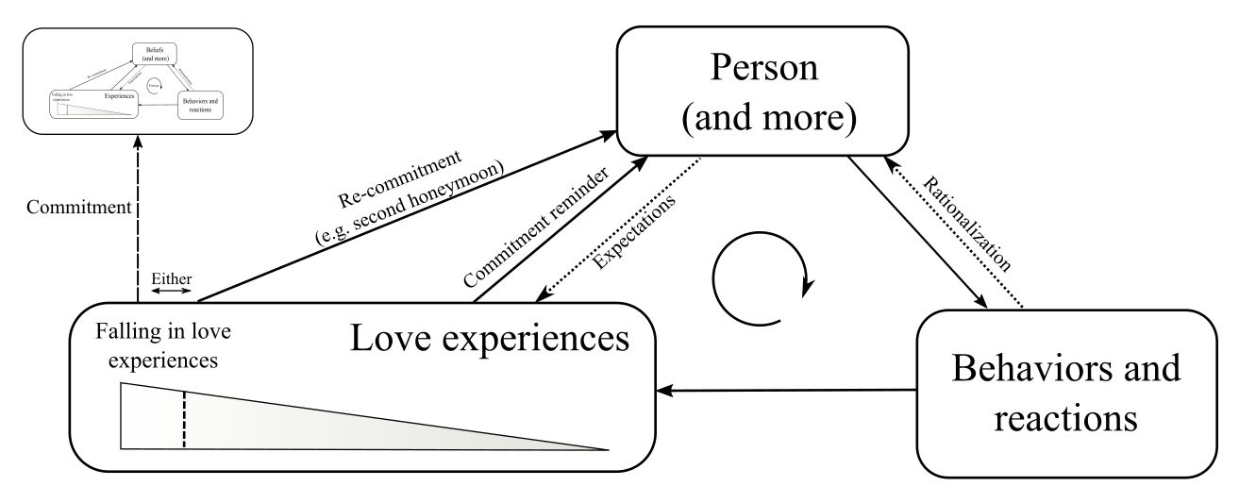
Experiences that feature emotions other than love can also affect the love feedback. These can be positive emotional experiences—such as pride directed toward a loved one—or negative emotional experiences—such as fear or anger—which are directed toward people or things that threaten a loved one. But in most cases, the experiences that maintain the feedback loop are everyday interactions, and occasional special events, such as birthdays or anniversaries.
The fervor feedback
Awe experiences also generate a feedback, which I will call the “fervor feedback.” The feedback is established when a belief system leads believers to behave and react in ways that bring about awe experiences. When these experiences are interpreted in a way that maintains or strengthens the initial commitment, the feedback loop is complete.
Figure 2: The fervor feedback
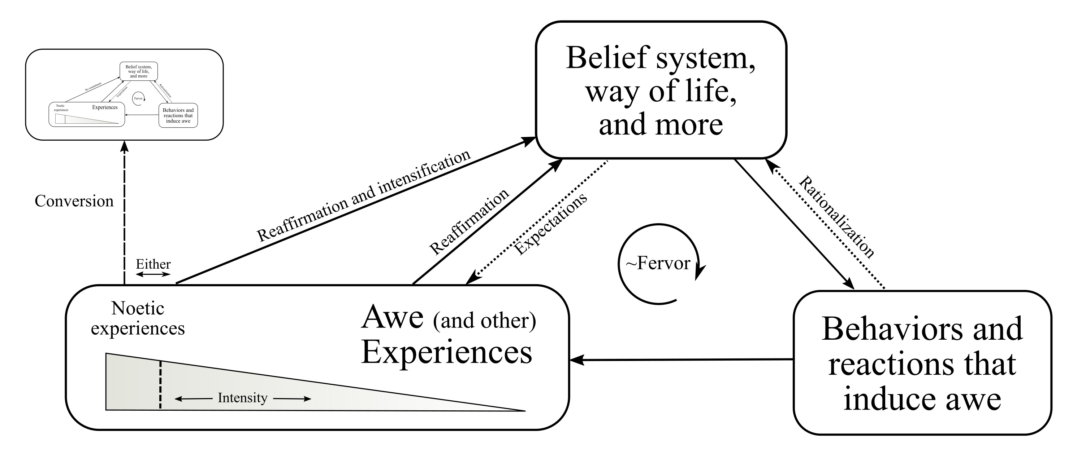
As with the love feedback, the fervor feedback results in recurring awe experiences. Often these take the form of everyday rituals such as saying a blessing, praying, or making gestures connected with the faith, occasionally inducing a more intense experience through behaviors that we will discuss in the next chapter such as fasting or ingesting drugs. Even though such regularly occurring experiences tend to be significantly less intense than the noetic experiences that lead to a conversion, they are vital in maintaining the fervor feedback. The strength of this feedback partially determines whether a person will be a sober believer, in a state of fervor, or if they will abandon their belief attachment altogether.
Like the love feedback, the fervor feedback can also be maintained through various emotional experiences that are connected to a belief system or a group—for example through pride in the achievements of the group, or fear that outside forces are conspiring against it.
The strength of the fervor and love feedbacks corresponds to the intensity and frequency of the awe or love experiences. Often the feedbacks include a combination of intense but infrequent experiences, and more frequent, less intense experiences.
The threshold effect of infatuation
Figure 3 is a graph depicting the relationship between a person’s level of infatuation (the Y axis) and the intensity of the fervor or love feedback (the X axis) which is determined by a combination of the strength and frequency of awe or love experiences. This graph assumes a constant level of stress. The effects of stress will be discussed next.
Figure 3
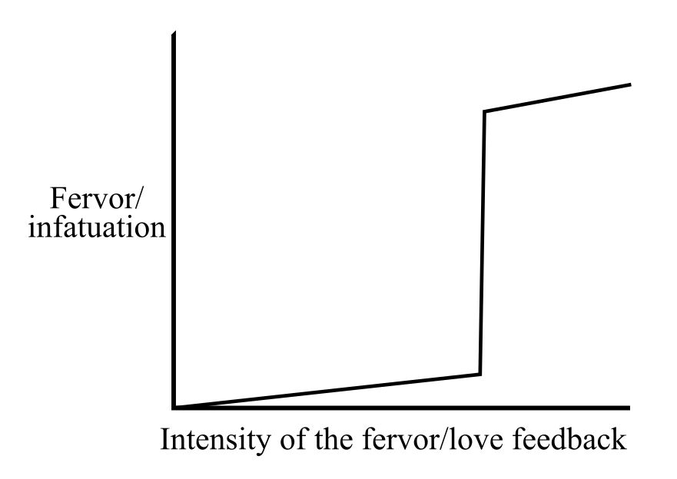
As the strength or frequency of awe or love experiences increases, the person’s level of infatuation grows. This growth continues linearly until the intensity of the love or fervor feedback passes a certain threshold. At this point the level of infatuation can suddenly shoot up, making the person fervent or infatuated.
Following a sudden conversion or a falling in love, people tend to be infatuated, at least for a while. But when people fall in love gradually or convert gradually from one faith to another, they may skip the infatuated mode altogether. This does not mean that their love or belief attachment is weaker or different from that of people who went through an infatuated phase.
The effects of stress on infatuation
So far, I discussed the level of infatuation as it relates to recent noetic or falling-in-love experiences, and to the strength of the fervor and love feedbacks. Let’s add another important parameter—stress. In the next chapter, we will discuss how stressful and traumatizing events can induce awe and love experiences; however, here we will focus on the effects of chronic stress on infatuation. I will use stress as a general term that includes various forms of PTSD, anxiety, urgency, guilt, insecurity, or uncertainty.
The connection between religiosity and stress in the form of trauma and suffering has been noticed by many thinkers over the years. Benedict De (Baruch) Spinoza, David Hume, Ludwig Feuerbach, and Sigmund Freud held the view that religiosity’s function is to alleviate hardship and help people cope with the fear of death. [Footnote: The problem with considering religiosity’s function to be an emotional crutch is that, while sometimes religiosity serves as an emotional crutch, helping people cope with stress, there are also examples of faiths that cause hardship and amplify the believer’s fear of death.] Stuart Guthrie writes: “Certainly, suffering and anxiety correlate with religiosity in some way. Old age, sickness, death, natural and social cataclysms, tragedy of all sorts, the unknown and the unexplainable, all have a long and widespread connection with religious enthusiasm” (p.10-11).
The stress-alleviating power of love experiences makes sense in the context of child-to-parent love, where parents alleviate a child’s stress and stress causes children to seek their parents. Other attachments can also relieve stress. People experiencing extreme levels of stress, such as torture victims, attempt to sooth themselves by thinking about objects of attachment such as loved ones, religious beliefs, deities or authority figures (Taylor, 2006, p. 212). In chapter 5 I will discuss how cults and abusive family members or romantic partners make use of the stress-alleviating power of love and awe to trap people.
Love and awe experiences do alleviate stress, at least temporarily, and suffering chronic stress makes such experiences more common and amplifies their intensity. In some cases stress makes people seek love and awe experiences. This is why cults recruit in places where people are likely to be stressed or disoriented, such as university campuses and prisons, and why people are more likely to join a cult after a romantic break-up, a move, or a change of job.
Let’s consider the effects of chronic stress on the relationship illustrated in figure 3. With increased stress the slope of the graph becomes steeper, and the threshold to infatuation moves leftward.
Figure 4
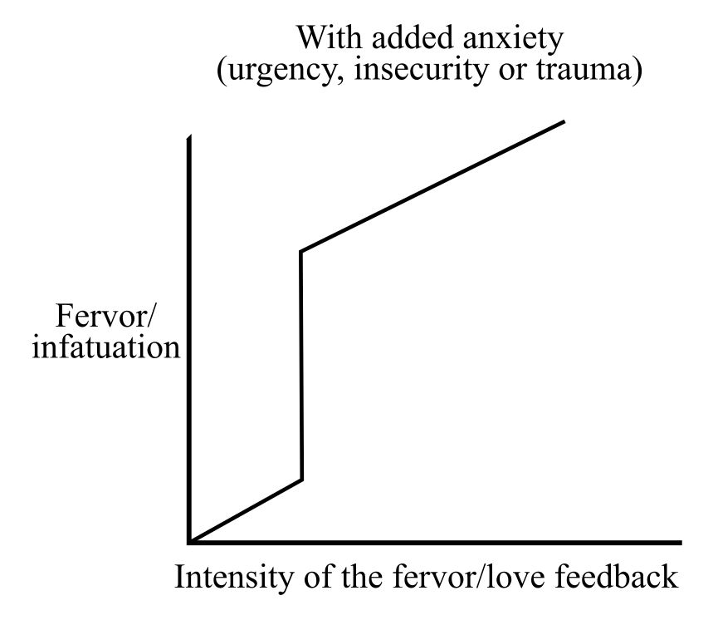

Because stress elevates levels of infatuation, certain faiths actively stress their believers. Examples can be seen in faiths that postulate grave after-life consequences to everyday actions, or in the following quote from a Scientology policy letter called “Keeping Scientology Working”:
We're not playing some minor game in Scientology. It isn't cute or something to do for lack of something better.
The whole agonized future of this planet, every man, woman and child on it, and your own destiny for the next endless trillions of years depend on what you do here and now with and in Scientology.
This is a deadly serious activity. And if we miss getting out of the trap now, we may never again have another chance. (Hubbard, 7 February 1965)

Guilt, brought about through the imposition of impossible expectations, is a common source of stress. For instance, various New Thought movements, including Scientology, claim that sickness and injury are the consequence of bad actions or thoughts. For example, having doubts about Scientology or communicating with someone who is critical of Scientology or its leadership, can, according to Hubbard, result in the person getting sick. So, when Scientologists do fall ill, as we all do, they feel guilty. This guilt brings with it anxiety and insecurity which increase the believer’s level of infatuation by the increasing the frequency and amplifying the intensity of awe experiences.
In his book The Power of Habit, Charles Duhigg (2014) notes that former alcoholics are likely to start drinking again following a stressful or traumatic event. He points to studies that show that those alcoholics who believed that some higher power had entered their lives were more likely to make it through the stressful periods with their sobriety intact (p. XX). It could be that for these people, the increased stress did not lead to drinking because it had the effect of intensifying their infatuation with a belief attachment that they associate with sobriety.
Stockholm Syndrome
When stress reaches a sufficiently high level, any awe or love experience can result in infatuation. This supports the assertion that using torture, people can be “brainwashed” to believe or love anything (or almost anything).
Figure 5
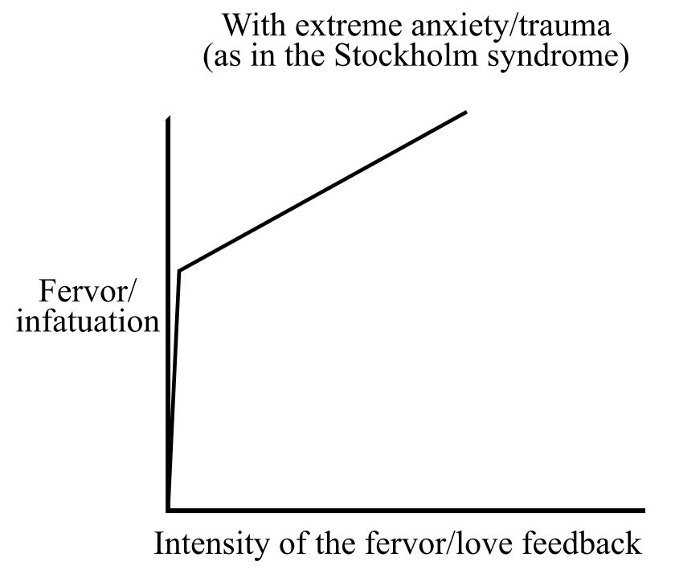
This relationship between stress and infatuation might account for Stockholm Syndrome, where people who are held captive develop an alliance with their captors. The story of Patty Hearst made this syndrome famous, when after being violently abducted she was held in a closet, blindfolded, with her hands tied for a week. Two and a half months later, she participated in a bank robbery wielding a rifle alongside her captors. This was possible because the tremendous stress of her experience greatly reduced the level of awe or love needed to put her in a state of infatuation. Once infatuated, it was natural for her to identify and cooperate with her captors.
A central plot point in Kubrick’s classic movie A Clockwork Orange (1972) shows the protagonist being tortured while Beethoven’s 9th symphony plays in the background. In the movie, this results in the victim developing an aversion to the symphony, feeling nausea whenever he hears it. However, it is also possible for the situation to create the opposite effect. A Palestinian friend of mine was tortured in Israel (details are given in the notes). Normally his torture was accompanied with loud, repetitive electronic music, but sometimes a soldier watching him played an album of Israeli singer Zohar Argov. To this day he is a fervent fan of Argov, and will sing along with songs in a language he does not understand.
[Footnote: My friend, who wishes to remain anonymous, was 18 when he was yanked out of bed in the middle of the night, and taken to a doctor to see if he was healthy enough to be tortured(!). He spent the next two months with a weekly routine starting with five continuous days of sleep deprivation, tied to an excruciating torture device that the CIA refers to as a “Palestinian chair” (Fair, 2016). Three times a day, he was given a five-minute break to eat, drink and go to the bathroom, but remarks that eating is not very important as we tend not to digest when being tortured. During these five days his head was covered with a sack which stank of either urine or vomit, and was forced to listen to loud repetitive noises resembling electronic music (save when a Zohar Argov album was played). After five days, he was put in a cell to sleep and recover for a couple of days before the routine began again. To this day, he has no idea why he was subjected to torture.]
Blind spots caused by infatuation
The sense of certainty that accompanies infatuated states depends on the infatuated person ignoring any contradicting information or major flaws in the object of infatuation. As such, infatuated states come with various “blind-spots,” altering perception and preventing anything from interfering with the infatuation.
Although I call the various types of misperceptions regarding the object of infatuation “blind spots,” they don’t always take the form of blindness (as in “love is blind”). In many cases, those flaws in the object of infatuation that contradict an idealized view are downplayed, given a positive interpretation, or emotionally ignored, while positive features are emphasized and exaggerated.
There are many causes for blind spots and biases. Rationalization in the form of motivated reasoning and cognitive dissonance avoidance, which will be discussed in a later chapter, can cause blind spots, as do psychological conditions such as personality disorders. In addition, various cognitive biases, emotional arousal, social pressure, and sources of authority can result in blind spots and a general distortion of perception and judgment.
While all of these are important I argue that when it comes to the infatuated states, another source of blind spots plays an important role. I am referring to the tendency of parents to see their children in a positive light so that they will take care of them regardless of any flaws they might have. This bias is so strong that some primate mothers will even continue to try and take care of a baby who has passed away (Hrdy, 2000).
I argue that romantic love and fervor inherited the parental blind spot from their evolutionary predecessor, parental love. In limerence, the blindness is not directed toward a child but toward a romantic interest, and in fervor it is directed towards a belief system which might include authority figures, groups, doctrines, or abstract entities.
Earlier, I discussed how noetic experiences can make people hold contradictory beliefs and believe that paradoxes are true. In many cases this is done with full awareness of the contradiction. But in other cases the certainty that comes with noetic experiences includes blind spots that obscure the fact that a belief system contains contradictions.
Consider a prosperity theology believing Christian who undergoes a noetic experience at church. The experience proves to her that the Bible is true, that her pastor is authentic and should be obeyed, and that she and her congregation are living in accordance with Christian principles and under the will of God. The same experience validates the Bible, with its demand that she give all her money to the poor, and her pastor’s preaching of the prosperity gospel, claiming that personal wealth is a reward that God bestows on those who have faith. The contradiction between the Bible and the prosperity gospel is obstructed by a blind spot. In most cases, people stick with their group’s social norms and way of life, which in this example means disregarding the biblical command and working to attain personal wealth.
This example also shows how a blind spot can make it possible for believers to ignore central tenants of their belief system. For example, a person might believe with all her heart that God takes care and provides for his believers. But taking this belief seriously and ignoring one’s personal needs can very quickly lead to a disaster. Thanks to a blind spot, it is possible for such a believer to ignore this deeply held belief and make the effort to provide for herself [ref Bulbulia]. In fact, it is often easier for people to ignore their most deeply held beliefs than it is to ignore ordinary truths.
Inability to perceive problems with an object of infatuation can result in over-sensitivity to criticism of a belief system or a loved one. Any criticism of an object of infatuation is likely to be dismissed, and the person voicing the criticism may come to be considered hostile. This dynamic is often seen when parents of an infatuated adolescent make the mistake of ordering their child to break up with a problematic romantic partner, or openly attack their child’s involvement in a cult. In many cases, the adolescent will be offended and outraged by the parents’ demand, sometimes even severing all ties with them which will make it harder for the child to break up with their romantic partner, or quit their cult, when their infatuation diminishes.
What happens to blind spots after infatuation fades
When infatuation fades, associated blind spots can also dissolve. In the case of limerence, people are sometimes shocked to discover just how much love blinded them. This notion is exemplified by the joke: Why is divorce so expensive?— Because it is worth it. In the same way, people sometimes leave a high-fervor group and are astonished to realize just how deceived they were.
Yet, in some cases people do not “open their eyes” as infatuation fades into sober attachment, but replace their blind spots with willful ignorance or rationalization. This makes it possible to keep wearing the rose-colored glasses which allow people to remain involved with an abusive group, romantic partner, or family member.
Once we have adopted a way of interpreting the world, it is hard to change. Taking a hard look at reality is, as the expression suggests, hard. This means that people who are embroiled in a high-demand group or cult, but are no longer infatuated with the group, might be too emotionally invested, exhausted and sleep-deprived to muster the energy to process information that would demand an overhaul of their worldview. I elaborate on how cults prevent members from leaving in chapter 5.
Examples of willful ignorance are found in Catholics who avoid news concerning the child abuse scandals plaguing their church, or in Zionists who disregard information about Israel’s treatment of Palestinians. As for romantic love, willful ignorance is exemplified in the TV series The Sopranos. The show focuses on an organized crime family led by an adulterous murderer. His wife Carmela chooses (without being fully aware of her choice) not to know what her husband does at work, since deep down she knows that the truth threatens her identity as a good person, and as a devoted wife and mother. She might have been blinded by limerence when she first fell in love with her criminal husband, but now that blindness has transformed into willful ignorance.
Love and awe providing a sense of meaning
Neurologist Robert A. Burton, mentioned earlier for his notion of “feelings-of-knowing,” points out that the feelings-of-knowing are not just sensory systems, but that they are also reward systems (2008). Familiarity can be comforting, realizations are inspiring, we like to feel that we are right, and curiosity can be a strong motivator. All of these involve feelings-of-knowing. I maintain that love and awe create a special version of the feelings-of-knowing, and as such, can bring about a special psychological reward—namely a sense of meaning and purpose.
Much has been made of the confusing and sometimes misleading question as to the meaning of life. Understanding “meaning” as a subjective feeling—which is the reward aspect of either awe or love—can help us to better approach this grand question.
There are countless examples where love and awe offer a sense of meaning. A secular example that involves awe is found in Jay Bulger’s documentary Beware of Mr. Baker (2012). In the documentary, legendary drummer Ginger Baker tells the audience: “Four drummers in my life that were absolute heroes: Phil Seamen, Max Roach, Art Blakey, and Elvin Jones. All four of them became friends, I mean friends, dear friends, and that to me is worth [choking with emotion] more to me than anything in the world.” Both meeting people one regards as celebrities and observing high levels of skill—in this case the drumming skills of Baker’s heroes—can induce awe. When Baker recalls his friendships with his idols, he is overwhelmed with awe, which seems to give him (a sense of) meaning.
In chapter 4 I will discuss how this sense of meaning and purpose interacts with personal identity to bring about what Eric Hoffer (1951) refers to as “a true believer.”
Similarities between attachments and addiction
Both limerence and fervor have been compared to addiction. While there are similarities between these states, there are also a number of important differences. The nature of addiction is complex, and it is a highly controversial subject which is mired in powerful economic interests. I first need to briefly discuss addiction, even though addressing the nature of addiction adequately is beyond the scope of this book.
The disease, choice, and learning theories of addiction
There are three prominent theories on addiction—there are those who view it as a disease, others as a choice, and others as a learned habit. The latter is sometimes referred to as the learning model of addiction. The disease model claims that addiction “kidnaps the brain” and deprives the addict from having a choice regarding her addictive behavior. As such, the disease model of addiction puts no blame on the addict. The choice model, in its pure form, claims that addicts freely choose to act on their addiction every time they do so, and that they can choose to quit their addiction at any time. This view blames the addict for her addiction. The learning model of addiction claims that addictions are a type of a learned habit. Regarding blame, the learning model takes a more nuanced approach where the blame is shared by the addict, society at large, and the specific circumstances of the case.
While the disease model of addiction is popular, it has been disputed for a while (for example Peele & Brodsky, 1975). A number of recent books convincingly argue that seeing addiction as a disease is both wrong and potentially harmful. These include Carl Hart’s High Price: A Neuroscientist's Journey of Self-Discovery That Challenges Everything You Know About Drugs and Society (2013), Mark Lewis’s The Biology of Desire: Why Addiction Is Not a Disease (2015), Maia Szalavitz’s Unbroken Brain: A Revolutionary New Way of Understanding Addiction (2017).
I support the learning model of addiction that views addiction as a type of habit [footnote: Focusing on habits rather than on actions is not new. Aristotle, for example, gave habits a central role in his account of human nature. Because habits defy the nature/nurture distinction, they tend to be neglected by theories that assume that such a distinction is fundamental. But, as Blaise Pascal told us in the 17th century, it is human nature to have a second nature]. As habits, addictions depend on a feedback between experiences, beliefs, and behaviors. In that regard they are similar to how I discuss love and belief attachments.
An important similarity between addiction and infatuated states concerns how they motivate people to be goal oriented while distorting their judgments. In some cases this can lead people to break other commitments and to act irrationally and selfishly.
While both addiction and infatuation distort people’s judgment, they do so differently. In the case of addiction, the distortion can be limited to times when the addict is in need of a “fix,” and it is common for people to genuinely hate their addictions. In the case of the infatuated states we see that the distortion in judgment is deeper and more consistent. [Footnote: I discussed earlier that as domesticated animals it is possible for people to love a wide variety of things. As such, it is possible for people to love the substance or behavior that they are addicted to and to have the type of blind spots that are associated with love.]
Addictions and infatuated states are also similar in the non-intuitive and non-linear way that they relate to stress (in the wider sense of stress discussed above). Earlier I discussed how stress can strengthen infatuation, yet at the same time, a sufficiently strong traumatic event can sometimes bring about a personal transformation which can also end a person’s infatuation.
We see that stress can strengthen infatuation in situations where the more abusive a cult or a romantic partner is, the harder it is for a person to leave. A similar dynamic can happen with addiction, where an addict who is under stress needs her “fix” more than one who is not stressed. This is why we should not punish people who are trapped in addictions, abusive relationships, or cults, as doing so often has the effect of strengthening the person’s addiction or infatuation.
The second effect of stress is the possibility that a strong traumatic event will induce a personal transformation. Such a transformation can include quitting an addiction and the ability to leave abusive partners or cults. Twelver-step programs, which view addiction as a disease, try to help people quit their addiction by inducing a personal transformation. Unfortunately, these programs insist that addicts must hit “rock bottom” before they can improve. While a sufficiently strong trauma can induce a noetic experience which can lead to a personal transformation, other ways to induce noetic experiences (which I discuss in the next chapter) seem much more inviting. For example, there is increasing evidence that the administration of psychedelic drugs within a therapeutic context can lead to a personal transformation which includes the quitting of an addiction (ref). This therapeutic possibility is available to addicts because, unlike people with fervor whose blind spots prevent them from seeing the faults of the objects of their fervor, it is possible for an addict to hate her addiction.
Maia Szalavitz (2017) points out that it is not uncommon for people to quit their addictions when they fall in love romantically. In this case, people take advantage of the transformative potential of falling-in-love experiences to quit an unwanted addiction.
In chapter 5, which is concerned with cults, I will return to the subject of addiction. I will show that the tactics that some cults employ to pressure people to make a bad decision, such as signing over their belongings to the cult, take advantage of psychological processes such as “ego depletion” and “now appeal” which also play an important role in how addictions can lead people to make bad decisions such as stealing from loved ones.
Important differences between parental infatuation, limerence, and fervor
So far, we have focused on similarities between parental infatuation, limerence, and fervor. Here I will discuss a number of differences between these psychological states.
We have already discussed one important difference: parental and romantic love manifest as a commitment to another person, but with fervor, people’s commitment also includes a commitment to the truth value of a set of ideas. The latter often includes total trust in certain authority figures which is seen in child-to-parent love but not in parental and romantic love. While it is entirely possible for infatuated parents and people in the grips of limerence to think that their loved one is wrong about something, a fervent believer in a God is not likely to even consider the possibility that her God has made a mistake.
Another key difference between the types of attachment lies in the triggers that bring about the emotions underlying them. At some point in human evolution, romantic love was born. It resembled parental love in many ways, but the triggers that established these types of love were completely different. In the framework of parenting, a sudden loving relationship is triggered by the arrival of a baby. In contrast, romantic love-at-first-sight is triggered in part by sexual attraction which is determined by sexual imprinting and by various handicapping displays (see appendix X) that rely heavily on a person’s history and on cultural and situational contexts. As such, it makes sense that when the new type of love appeared in the form of belief attachment, it too was triggered by entirely different stimuli. These triggers are the subject of the next chapter.
Belief attachments and child psychology
Up to now I have been discussing how belief attachments relate to the parental and romantic types of love. Here I discuss the tendency of belief attachments to include a childlike dependence, an aspect of belief attachments which is seen in child-to-parent love, and in child psychology in general.
Preadolescent children are dependent on parental figures. These parental figures can be the child’s biological parents, adoptive parents, or alloparents, such as grandparents or friends of the family. Parental figures provide a “secure base” in which the child feels calm and secure.
It has been argued, most famously by Sigmund Freud, that Gods and religious authorities play the psychological role of parents. In his book Them and Us (2003), psychiatrist Arthur Deikman maintains that people desire security through what he refers to as the “dependence dream.” He writes: “The wish to have parents and the parallel wish to be loved, admired and sheltered by one's group, continues throughout life in everyone … These wishes generate a hidden fantasy or dream that can transform a leader into a strong, wise, protective parent, and a group into a close, accepting family. Within that dream we feel secure.” (p. 9) He argues that the dependence dream is fulfilled by becoming dependent on a parent-like figure which is often associated with an institution or an affiliation.
In addition to providing a secure base, childlike dependence includes the unquestioning adoption of the parental figure’s worldview. The adoption of the worldview can happen even in cases where the dependent person does not know key details of the worldview which they claim to hold. This can be seen in how preadolescent children convert to a new religion when their parents do, even in cases where the children know next to nothing about their new faith.
In the case of childlike dependence which is part of a belief attachment, the ability to adopt a worldview while being ignorant of its details can most clearly be observed in people who undergo a sudden religious conversion. For example, it is possible for a person who is ignorant of the details of Mormonism to have a noetic experience which proves to her that Mormonism is the true faith, making her a fervent believer in a faith she is not that familiar with. The new convert gets along by observing the behavior of other believers and consulting with a religious authority or text when specific questions come up.
Because belief attachments are related to child psychology, age-regression makes it easier for adults to undergo awe experiences. In the next chapter I will discuss common age regression practices.
Overimitation
Children and adults with a childlike dependence depend on a parental or parent-like figure for their basic understanding of how the world works. This dependence has the interesting effect of making people “overimitate” authority figures. Overimitation is the name given to a tendency, seen in experiments, where young children observing an adult inefficiently operating a novel object tend to imitate the adult, including irrelevant actions such as tapping the side of a box three times before opening it (references in dissertation). Unlike human children, chimpanzees ignore the obviously irrelevant actions and simply open the box.
Overimitation is seen in children as early as two years of age and it is even more prominent in five year olds. One way to explain overimitation is to see it as a property of the type of dependence that human children have on parental figures. Human children do not assume that they know what actions are relevant and what are irrelevant, rather, they rely on authority figures to know which actions are relevant, resulting in overimitation.
We also see overimitation in adults with a childlike dependence on an authority figure. Let us imagine the Pope showing a believing Catholic how to open a box. If the Pope would perform irrelevant actions such as crossing himself and saying a prayer before opening the box, it is very likely that the observing believer would overimitate the Pope and also perform the irrelevant actions before opening the box.
There are many examples of belief systems that cause people to perform irrelevant actions such as sacrificing animals to appease angry gods, dancing for rain, and seeking blessings that ward off the evil eye. Overimitation does not explain the existence of such behaviors (I will return to these in chapter 4), but it does help us understand why people who see such irrelevant actions performed for the first time, often accept the relevance of these actions without question.

Conclusion

Very incomplete bibliography:

Burton, R. A. (2008). On being certain: Believing you are right even when you’re not. New York, NY: St. Martin’s Press.
Deikman, A. (2003). Them and us: Cult thinking and the terrorist threat. Berkeley, CA: Bay Tree Publishing.
Duhigg, C. (2014). The Power of Habit: Why We Do What We Do in Life and Business. New York: Random House Trade Paperbacks.
Hart, C. (2013). High Price: A Neuroscientist’s Journey of Self-Discovery That Challenges Everything You Know About Drugs and Society. New York, NY: Harper.
Hoffer, E. (1951). The True Believer: Thoughts on the Nature of Mass Movements. New York, NY: Harper & Row.
Hrdy, S. B. (2000). Mother Nature: Maternal Instincts and how They Shape the Human Species. New York, NY: Ballantine Books.
Hrdy, S. B. (2009). Mothers and others: The evolutionary origins of mutual understanding. Cambridge, MA: Belknap Press of Harvard University Press.
Lewis, M. (2015). The Biology of Desire: Why Addiction Is Not a Disease. New York, NY: PublicAffairs.
Peele, S., & Brodsky, A. (1975). Love and Addiction. Marlboro, NJ: Taplinger Publishing Company.
Persinger, M. A. (1987). Neuropsychological bases of God beliefs. New York, NY: Praeger.
Stein, A. (2016). Terror, Love and Brainwashing: Attachment in Cults and Totalitarian Systems. Routledge.
Szalavitz, M. (2017). Unbroken Brain: A Revolutionary New Way of Understanding Addiction. New York, NY: Picador.
Taylor, K. (2006). Brainwashing: The science of thought control. New York, NY: Oxford University Press.
Tennov, D. (1998). Love and Limerence: The Experience of Being in Love (2nd edition). Lanham, MD: Scarborough House.

